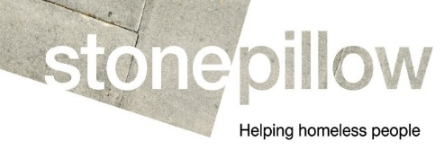
Person Specification
HARP Navigator

This person specification lists the skills, knowledge and experience required. You should provide evidence, in the form of an example, that you meet each criteria on your application form.

E = Essential criteria D = Desirable criteria

Criteria | E | D
Knowledge
- Good knowledge of welfare benefits, housing and homelessness law and policy. | E
- Good knowledge of alcohol, drugs and issues around addiction and relapse management | E
- Good knowledge of mental health, personality disorders and dual diagnosis | E
- Good knowledge of Health and Safety, Safeguarding and Confidentiality | E
- Good knowledge of local agencies providing services relevant to the client group. | D | D
Skills
- Commitment to and good understanding of equality and diversity | E
- The ability to forge effective working relationships within a team | E
- The ability to forge effective working relationships in order to navigate and to create effective pathways to support for clients with complex needs acting as a change broker | E
- Ability to communicate with a wide range of people using excellent active listening skills to form healthy and constructive relationships | E
- Commitment to personal growth and extending own professional competence and knowledge. | E
- Good computer literacy skills and ability to make effective use of systems | E
- Experience of delivering support to vulnerable people | E
- Experience of providing support to people with multiple needs | E
- Proven ability to work effectively within a partnership along with the ability to advocate effectively at all levels on behalf of homelessness clients. |  | D

